Python Strings
Python string is a built-in type text sequence. It is used to handle textual data in python. Python Strings are immutable sequences. Creating Strings are simplest and easy to use in Python.

Accessing Python Strings
In Python, Strings are stored as individual characters in a contiguous memory location. The benefit of using String is that it can be accessed from both the directions (forward and backward).
Both forward as well as backward indexing are provided using Strings in Python.
Forward indexing starts with 0, 1, 2, 3, ....
Backward indexing starts with -1, -2, -3, -4, ....
Example
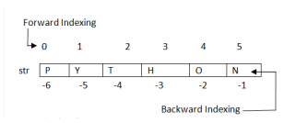
Example to print each letter in a Word

String Operators
To perform operation on string, Python provides basically 3 types of Operators that are given below.
- Basic Operators
- Membership Operators
- Relational Operators

String Basic Operators
There are two types of basic operators in String + and * .
- Concatenation Operator (+)
The concatenation operator (+) concatenates two Strings and creates a new String.

Example
- Replication Operator (*)
Replication operator uses two parameters for operation, one is the integer value and the other one is the String argument.
The Replication operator is used to repeat a string number of times. The string will be repeated the number of times which is given by the integer value.
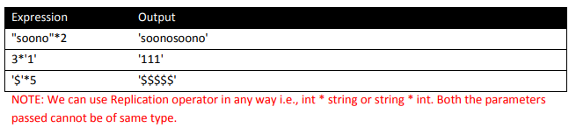

String Membership Operators
There are two types of Membership operators
- in : "in" operator returns true if a character or the entire substring is present in the specified string, otherwise false.
- not in :"not in" operator returns true if a character or entire substring does not exist in the specified string, otherwise false.
String Relational Operators
All the comparison (relational) operators i.e., (<=, >=, ==, !=, <, >) are also applicable for strings. The Strings are compared based on the ASCII value or Unicode.
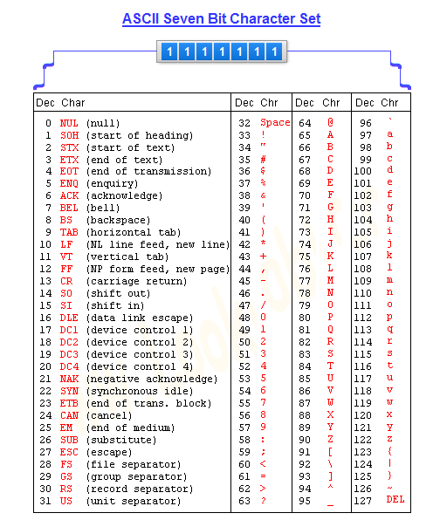
Example
String Slice Notation
Python String slice can be defined as a substring which is the part of the string. Therefore further substring can be obtained from a string.
There can be many forms to slice a string, as string can be accessed or indexed from both the direction and hence string can also be sliced from both the directions.

String Functions and Methods
Python provides various predefined or built-in string functions. They are as follows:
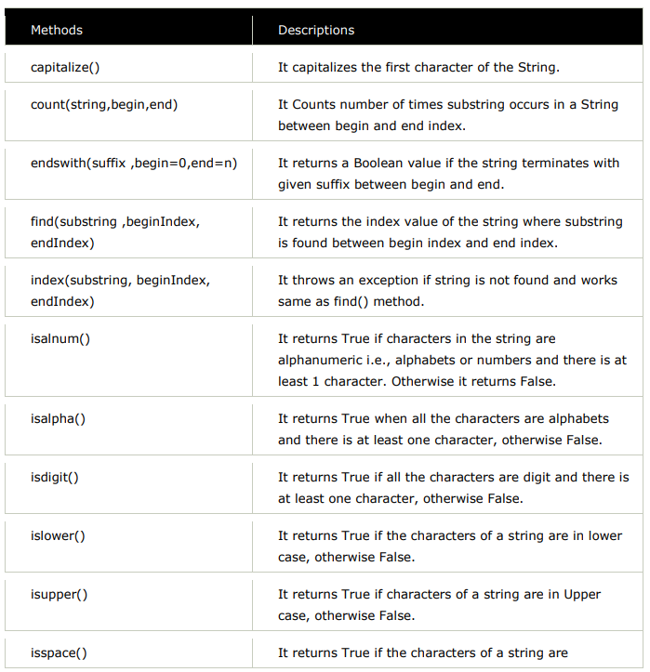

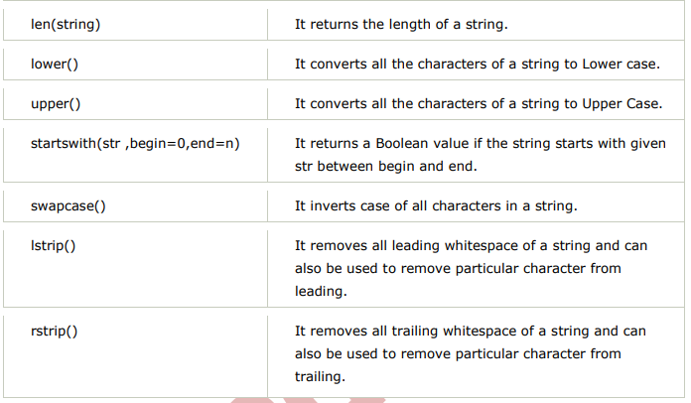

1) Capitalize()
This method capitalizes the first character of the String.
2) Count()
This method counts number of times substring occurs in a String between begin and end index

3) Endswith()
This method returns a Boolean value if the string terminates with given suffix between begin and end.

4) Find()
This method returns the index value of the string where substring is found between begin index and end index.
5) Index()
This method returns the index value of the string where substring is found between begin index and end index.

6) Isalnum()
This method returns True if characters in the string are alphanumeric i.e., alphabets or numbers and there is at least 1 character. Otherwise it returns False.
7) Isalpha()
It returns True when all the characters are alphabets and there is at least one character, otherwise False.
8) Isdigit()
This method returns True if all the characters are digit and there is at least one character, otherwise False.

9) Islower()
This method returns True if the characters of a string are in lower case, otherwise False.
10) Isupper()
This method returns False if characters of a string are in Upper case, otherwise False.
11) Isspace()
This method returns True if the characters of a string are whitespace, otherwise false.
12) Len()
This method returns the length of a string
13) Lower()
It converts all the characters of a string to Lower case
14) Upper()
This method converts all the characters of a string to upper case.
15) Startswith()
This method returns a Boolean value if the string starts with given str between begin and end.
16) Swapcase()
It inverts case of all characters in a string.
17) Lstrip()
It removes all leading whitespace of a string and can also be used to remove particular character from leading.
18) Rstrip()
It removes all trailing whitespace of a string and can also be used to remove particular character from trailing.
QUIZ
- Write a Python program to calculate the length of a string entered by User.
- Write a Python program to reverse a string entered by User.
- Write a Python program to get a string made of the first 2 and the last 2 chars from a given a string.
String: 'aeroplane'
Answer: 'aene'
- Write a Python program to get a string from a given string where all occurrences of its first char have been changed to '#', except the first char itself.
String: 'aeroplane'
Answer: 'aeropl#ne'

HW
- Remove the even index characters from the string entered by User.
String: “PythonisGreat”
Answer: “PtoGet”

- Write a Python program to reverse a string if it's length is a multiple of 4.

